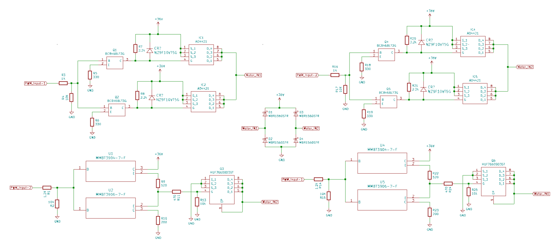
MOSFET connection for the H bridge
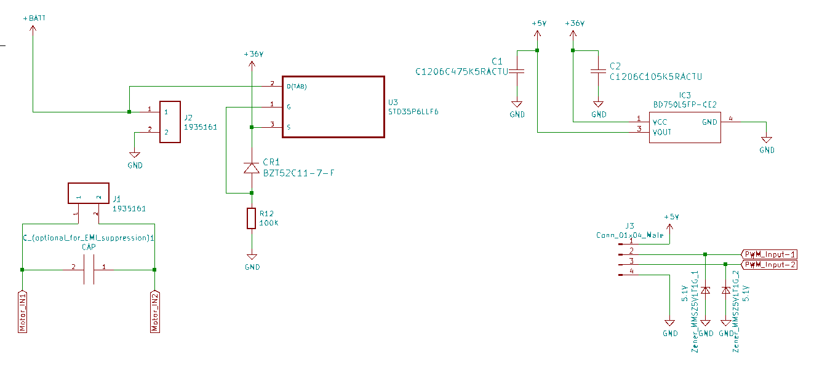
Linear regulator to convert battery voltage into 5 v, Reverse Polarity protection using a P channel MOSFET

This is the motor driver circuit that can be used to drive motors at 36 volts and 10 amp continuous/ 30 amp pulsed current.
As per the guidelines set by the challenge, only the IC used were a microcontroller ATtiny10 (not mentioned in the schematic) and a linear regulator IC (BD750L5FP-CE2) that can act as a Battery eliminator circuit for low power controllers.

Parts Used
All components are SMD
P-Channel MOSFET: AO4421 | MOSFET P-CH 60V 6.2A 8SOIC
Hence 2 used in parallel to increase the current sourcing capability to the motor. Also, using 2 mosfets in parallel reduces the heating effects as well as drain-source ESR resistance.
Zener diodes NZ9F10VT5G used to maintain Vgs = 10 V for minimum Drain-Source Resistance, each driven by BC846BLT3G transistor. This is where we apply the PWM pulse.
N-Channel MOSFET: HUF76609D3ST | MOSFET N-CH 100V 10A DPAK
Used 1 to sink the rated current coming from the motor. Totem pole arrangement (MMBT3904 and MMBT3906) for driving this transistor used. Resistor configuration a max passage of 50 mA while driving the mosfet with Vgs = 10 V for minimum Drain-Source Resistance.
MBR1560SRT Schottky diodes used for commutation-spike protection and freewheeling purposes.

STD35P6LLF6, P-channel MOSFET employed for reverse polarity protection and Schottky BZT52C117F keeps its Rds minimized.
BD750L5FP-CE2 IC REG LINEAR 5V 500MA TO252-3 to power the microcontroller.
Zener MMSZ5V1T1G to ensure that heavy spikes do not destroy the transistor gates/pwm pins.

PCB specifications
Everything is SMD except for the terminal blocks. Space efficiency via SMD components whereas terminal blocks require stronger connection.
2 Oz Cu PCB recommended. Via Stitch for EMC/EMI considerations and also recommended metal enclosures that can also act as heat sinks.

How firmware is written
The PWM is generated in the peripheral using fast non-inverted PWM mode. The microcontroller is at 8MHz and the prescalar clocks it down to 1MHz in the timer module. The frequency of PWM is 100Hz and the duty cycle increase/decreases 1% every 50ms.
Interrupt based timer also keep a track of elapsed time. After ever 5 seconds, the state of the machine is changed and follows the sequence as directed while ensuring that there are no faults.
Error rate is negligible as the compare registers are double buffered and Input capture register value is static.

